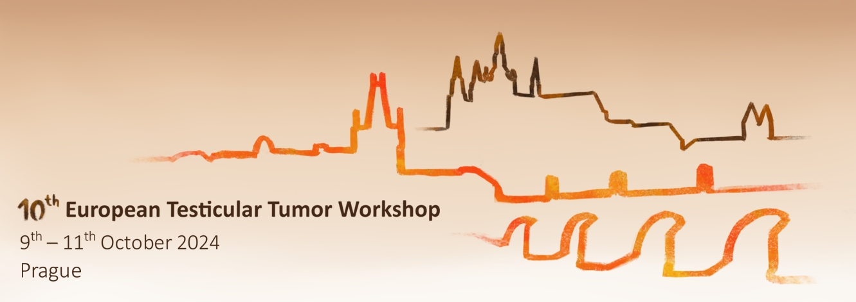

[**www.ettw.eu**](http://www.ettw.eu)

**On behalf of the Organizing Committee, we are pleased to announce the 10th European Testicular Tumor Workshop scheduled for 9th–11th October 2024, Prague, Czech Republic.**

*In collaboration with* **TECAC – Testicular Cancer Consortium** [www.med.upenn.edu/tecac/](https://www.med.upenn.edu/tecac/)

**MaGIC – Malignant Germ Cell International Consortium**

[www.magicconsortium.com](http://www.magicconsortium.com)

*Organizer:* Thomayer University Hospital, 1st Faculty of Medicine and 2nd Faculty of Medicine, Charles University, Czech Republic

*Co-organizer:* Rigshospitalet and University of Copenhagen, Denmark; Faculty of Medicine, Comenius University, Bratislava, Slovenia; Perelman School of Medicine, University of Pennsylvania, USA

*Scientific Program Committee:* E. Rajpert-De Meyts, K. Almstrup, G. Daugaard, K. Nathanson, M. Chovanec, L. Boublikova

*Contact person:* Ludmila Boublikova, MD, PhD, Dept. of Oncology, Thomayer University Hospital, Videnska 800, 140 00 Prague 4, Czech republic, email: [ludmila.boublikova@ftn.cz](mailto:ludmila.boublikova@ftn.cz), phone: +420 2 6108 3890

*Organizing agency:* AMCA - Academic and Medical Conference Agency, Vysehradska 320/49, 128 00 Prague 2, email: [amca@amca.cz](mailto:amca@amca.cz), phone: +420 731 496 060

*Location:* Emmaus, Vysehradska 320/49, 128 00 Prague 2 – Nove Mesto

Registration on-line here: <https://www.ettw.eu/registration-0>

or during the conference at the conference venue

The event is accredited by Czech Medical Chamber with 13 credits.